Hey, welcome to my website on my many confessions about being a Montessorian and currently a public school Montessorian who aims to have authentic Montessori in my environment. I am a musician by trade, and changed carriers in my mid-twenties after reading several of Dr. Maria Montessori’s books. I am an AMI trained primary guide and I loved every minute of my training. My life revolves around my family, friends, Montessori and music.

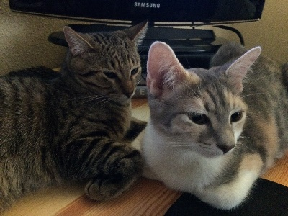I live in Austin, TX with my wonderful husband, Evan, who is gracious enough to help me begin this all too personal task of sharing my experience online for others to read. Oh, and also to critique! We have expanded our little family in the past year with the addition of two young kitties named, Remy and Leloo. They can make a mess but we love them all the same. During down time I like to read, sew, and I also enjoy thinking about attending yoga. I also love breakfast tacos!

This is a place where I will share my thoughts on what I learn throughout my time as a Montessorian. I hope others will share their thoughts and experiences with me even when our opinions may be different.